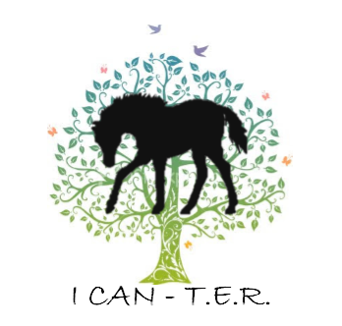
I CAN-T.E.R.
Fall Into Wellness
Outdoor Program
“Equestrian Field of Dreams”
1234 House Rd. RR1
Ridgeway, ON
L0S 1N0
905-894-FARM (3276)
www.icanter.ca
icanter@icanter.ca
www.facebook.com/icanter

Details
Who Can Come: Youth Ages 10-15 (ages may vary for individuals with a disability)
Dates: Saturdays From October 23rd – November 27th

Hours: 1:00pm to 4:00pm
Price: $180 for all sessions (To be paid in full and to accompany your registration form).

*Cancellation policy: Non-refundable unless cancellation is one week-in-advance and your spot can be filled. Refunds are available in the event that the program is cancelled due to lack of minimum registration. The program is limited to 10 participants – first come, first served! Registration forms are available on our website at www.icanter.ca

Please send these items with your child so that they will be ready for all that our outdoor wellness program has to offer:
Hand sanitizer, water in reusable bottles, mask, BOOTS, and a light snack.
Most importantly: Dress for the weather!!! Please bring warm clothes like extra fleece jackets, hats, mitts, splash pants, boots, etc.

Please Note Foot Wear Policy: NO sandals, crocs or open-toe foot wear allowed FOR SAFETY REASONS AND INSURANCE COMPLIANCE. Due to the nature of the program - being outside and around nature, a sturdy closed toed shoe or boot is mandatory.

Please consider the following:
- Bring a filled reusable water bottle to limit the amount of plastic and waste
- Bring a snack! We will provide everyone with the chance to take a nutrition break. All snacks must be peanut free and please try to avoid sugary or sweet snacks/drinks as they attract bees
- Masks are not mandatory for outside and when socially distanced, but must be worn in the barn, so please pack one.
- Programming will continue to run whether its rain or shine. Please come prepared with proper clothing depending on the weather
- COVID screenings are mandatory prior to arriving at the wellness program. These can be filled out online on our website, OR printed and handed in upon arrival

